

4004 MOULTON ST.

GREENVILLE, TEXAS 75402

903.457.2500

WWW.GREENVILLEISD.COM

GREENVILLE ISD

BUDGET 2016

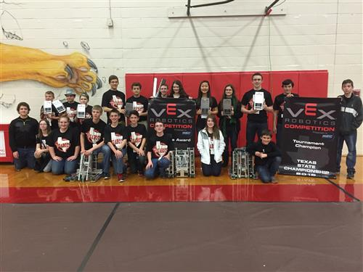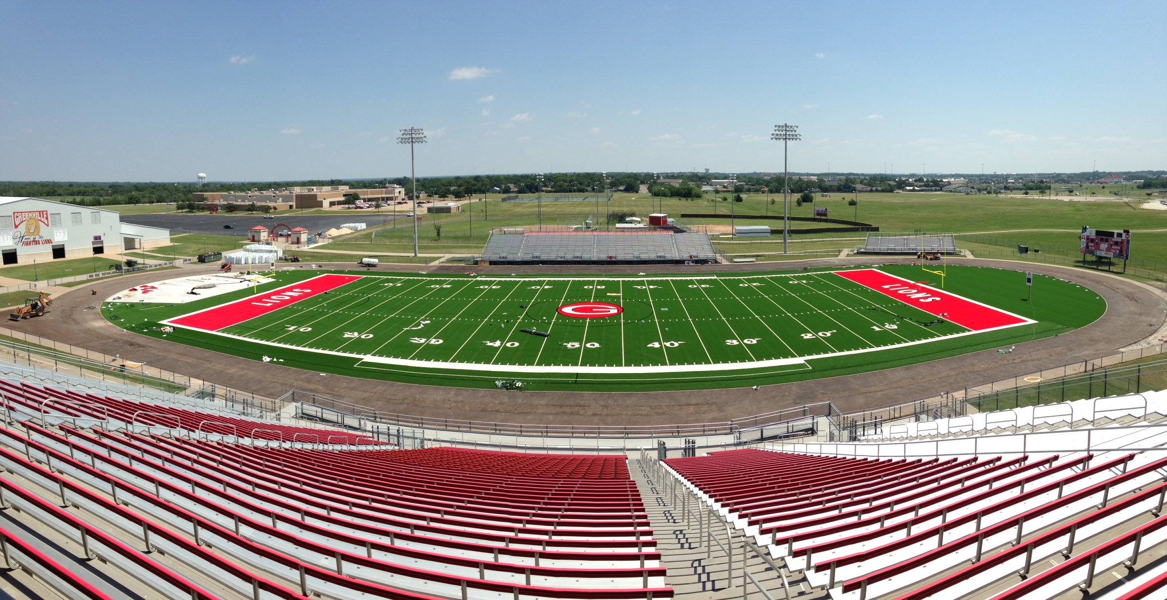



**M E M O R A N D U M**

**Greenville Independent School District**

**TO:** Board of Trustees

Mr. Don Jefferies, Superintendent

**FROM:** Billy Myers, RTSBA

Chief Financial Officer

**DATE:** August 16, 2016

**SUBJECT:** 2016 – 2017 Proposed Budget

The following pages contain the 2016-2017 Budget for the General Fund, Student Nutrition Fund and Debt Service Fund.

Significant budget factors**:**

* **Student Enrollment Growth.** District enrollment increase by 478 students in 2015-2016. Conservative enrollment projections are indicating an increase of approximately 100 students.
* **Taxable Value Increase.** Certified taxable values were received from the Hunt County Appraisal District on July 20, 2016. Taxable values for 2016 represent approximately a $139,091,059 increase in values from the previous year. Total taxable property value for 2016-17 is $1.826 billion, as compared to last year’s $1.687 billion.
* **Tax Rate.** The proposed property tax rate for 2016-17 is:

Maintenance & Operations $1.04000

Debt Service $0.26917

Total Tax Rate$1.30917

* **Salary Increases.** Included in the 2016-2017 budget is an across the board salary increase. The beginning pay for new teachers will be $42,300 and every step has been increased by $1,500, a 3.0% from mid-point increase for all Instructional Support; Administrative support; and Auxiliary, as well as, a 3.0% from mid-point pay increase for all Administrative Professional.



**Greenville Independent School District**

2016-2017 Proposed Budget Recap



**Greenville Independent School District**

***GENERAL FUND***

2016 - 2017 Proposed Budget

General Fund

**Greenville Independent School District**

***STUDENT NUTRITION FUND***

2016 - 2017 Proposed Budget

Student Nutrition Fund



**Greenville Independent School District**

***DEBT SERVICE FUND***

2016 - 2017 Proposed Budget

Debt Service Fund

